**Unit 1 – Images and Pixels**

**Image Acquisition**

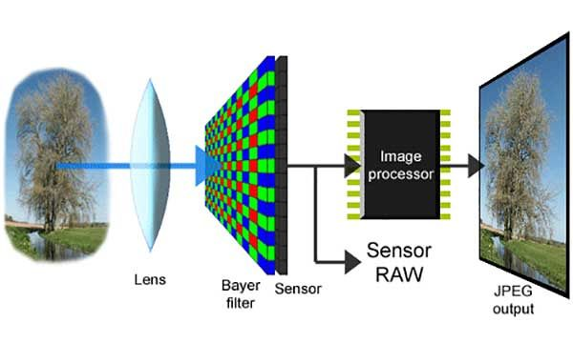 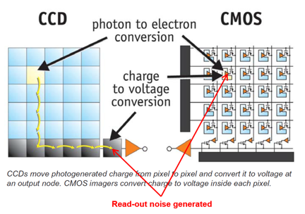

A digital camera will use light sensors such as CMOS and CCD, which measure light, made of a matrix of small light censors measuring the amount of light which hit an individual cell and converting a photon charge to an electron.

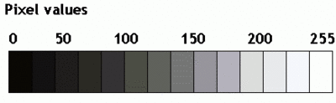 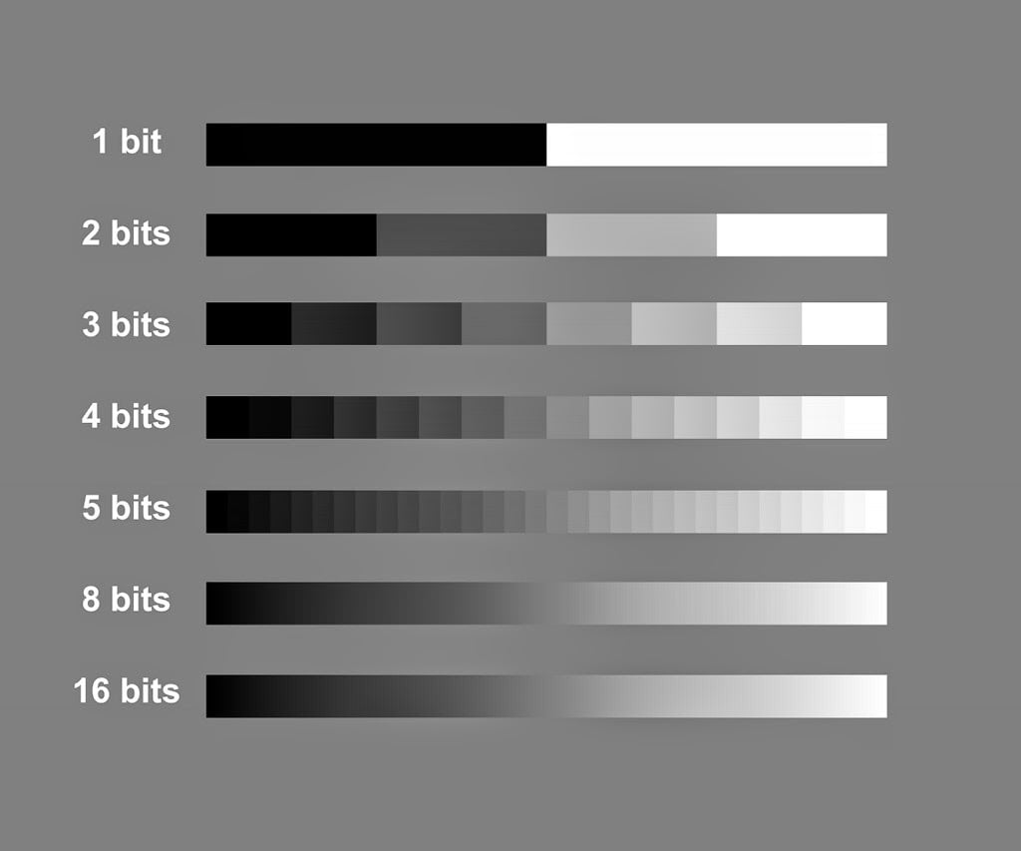

216 levels

23 levels

28 levels

25 levels

24 levels

22 levels

21 levels

To create an image each sensor cell can be converted into one pixel, and we interpreted the amount of light hitting the sensor using a grey level of the pixel. If no light hit the sensor the grey level = black (0), and if the light is very strong then grey level = white (255). Depending on the number of bits available we can enable different shades of grey (powers of 2, to allow encoding conversion). Note that the sensor only extracts a finite number of points that was captured in order to represent the image (continuous scene).

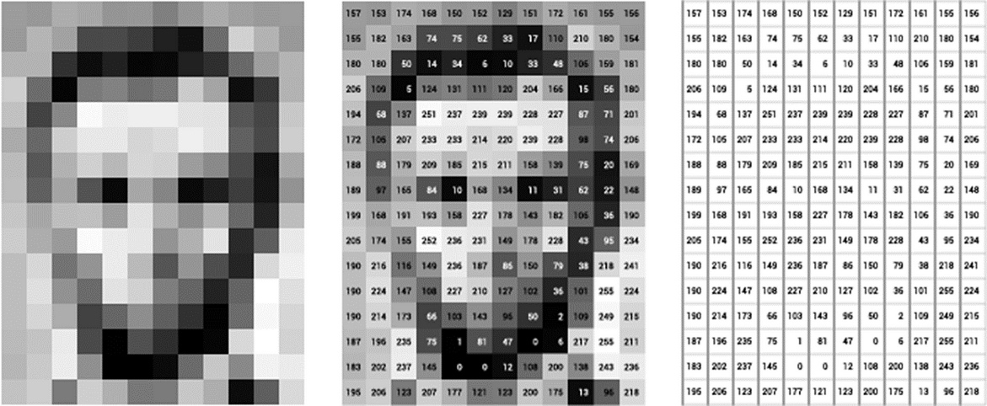

**Sampling and reconstruction of functions**

Grayscale image – A 2D grid of values representing the light intensity at some sample points in the scene. We can create and graph to represent the digital photo where x and Y axis represent the image itself and the Z axis represents the grey scale of the represented as a **scaler** value over the function of the image.

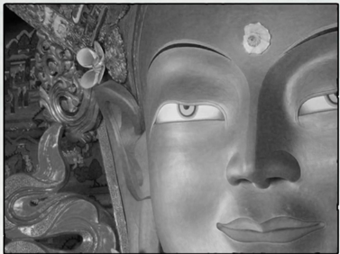 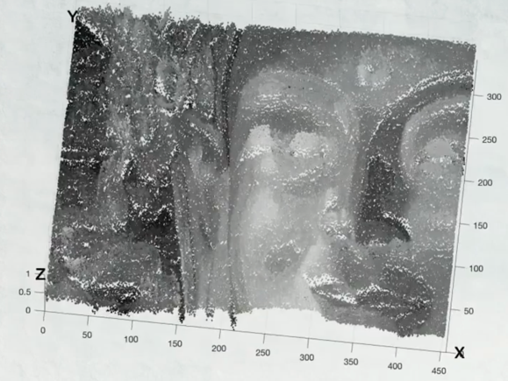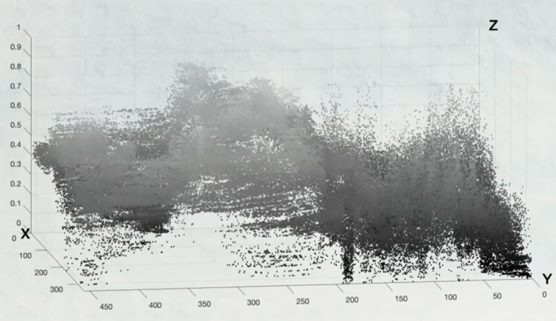

Consider a one-dimensional continuous function y = f(x) to **“digitally capture”** this function means taking a finite # of points along the function and storing those values in an array. To **“reconstruct”** the image is to use the values in the array to recreate the continuous function.

**Note:** Due to the difference in the number of points stored and the number of points in the function it is likely that in the reconstruction process the result will not be identical.

**Nyquist Shannon theorem**: “A signal can be reconstructed from its samples, if the original signal has no frequencies above ½ the sampling frequency.” Reconstruction ability links between the rate of sampling and rate of change.

Frequency (image) – rate of change in space

If our function changes a lot, then we’ll need more sample and if it changes slowly then less samples.

**Q. How do we reconstruct the image?**

Our image is defined as a piecewise constant function:

1. We have our sample of points
2. We uniformly divide our domain into uniform intervals
3. Assign the value of the sample point across their whole interval.

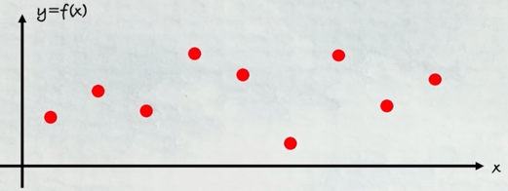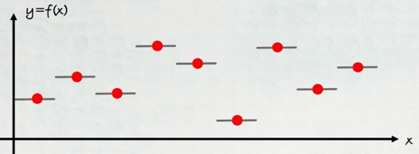

Note this means that the reconstruction isn’t continuous, and this is noticeable when looking very closely at an image and we can identify the discrete pixel values.

**Q. What if we want to define a continuous reconstruction from our sample?**

Apply the process of connecting the dots (piecewise linear). However, this isn’t smooth like the original function as such we’d require to use higher order functions to deal with this.

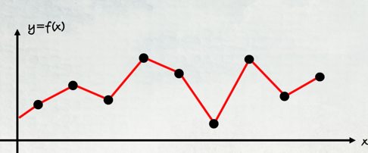

**Aliasing**

By the **Nyquist Shannon theorem,** we’ll investigate what will occur if the sample doesn’t contain at least 2x the amount of frequencies in the image. Notice that even when we know the function we wish to obtain if we don’t take enough samples would reconstruct an inaccurate version of the function, and we notice this is related to the frequency of the original function i.e. sample was less than 2x the frequency of the function (signal). This is known as **aliasing** – an effect that causes different signals to become indistinguishable.

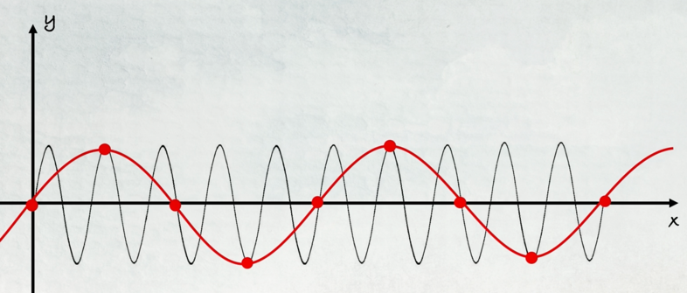

In a camera, the sampling rate is bounded by the number of light sensors and their capabilities. We must, therefore, find **anti-aliasing** methods to avoid producing inaccurate photos if possible.

**Image Scaling**

To improve the amount of detail in a photo we’d require to increase the number of pixels in the camera. (1 megapixels = 1 million pixels). A 36 megapixels can be defined by a rectangle of 7360 by 4912 pixels. Being provided the number of megapixels doesn’t tell anything about the image size.

Enlarging a digital image (from 12 megapixels to 36 megapixels) means adding additional pixels (24 million in our case). Scaling down an image is the reverse operation, i.e. removing pixels.

**Q. Which pixels do we remove and how do we do so?**

Uniform Scaling – when we scale the image size by the same factor on the horizontal and vertical dimension.

We choose part of the pixels to remain and discard the rest aka **sub-sampling.** We could removing every other pixel from the sampled photo in each dimension 🡪 scale 2 reduction in each dimension 🡪 factor 4 image size reduction.

If the old image size was p*q, then we must choose m and n such that p/q = m/n.

To choose the colour of each new pixel, we find the **closest** pixel in the old image to the centre of the new pixel and assign its colour to the new pixel – **nearest neighbour scaling**. However, the nearest neighbour method is prone to aliasing.

**Anti- Aliasing**

Non-Uniform scaling – When we use different scaling factor for each dimension.

The issue with non-uniform scaling is that artifacts can arise and can cause distortion of the image.

We now present a few methods which can allow us, to scale down an image whilst minimizing the Aliasing effect on the image.

**Nearest neighbour Sampling – Optimised**

Instead of choosing the nearest neighbour for our colour on the new pixel, we’ll have a neighbourhood around our new pixel and combine all their colour values to produce a more accurate colour on our new pixel.

A sample point will always lie between 4 closest pixels. With these 4 pixels colour values (made of R, G,B) and compute the average of them formally it looks like this:

C1

C2

C3

C4

**Averaging**

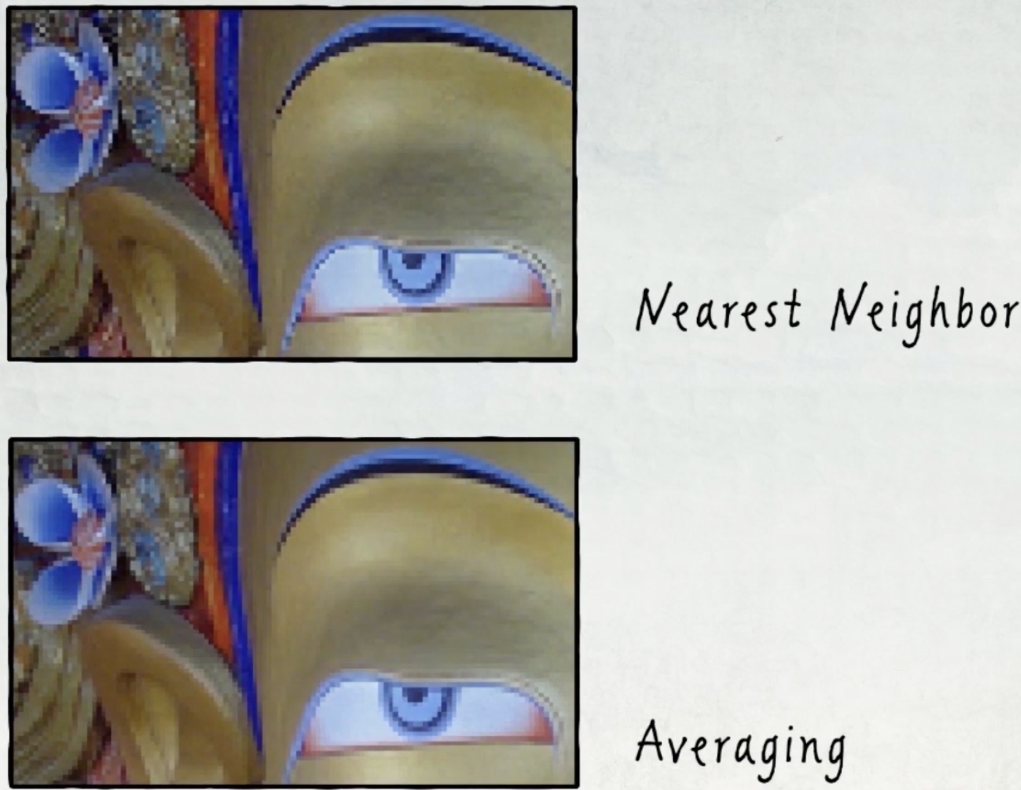

**Nearest Neighbor**



We compare the two methods, and do notice improvements however, there are still some staircase side effects visible. As such an improvement to this approach is to weight the pixel by its closest 4 neighbours and add more weight (have more of an effect) to the pixel which are closest to that sample point. (in our case, it would be the purple that has the most weight), a method that implements this idea is known as **bilinear interpolation.**

**Linear interpolation**

One Dimension

Given two points (x1, y1) and (x2, y2) on a graph, if we had a third x value between x1 and x2 we’d want to find a corresponding y value that is closest to these points. we may do this by finding the average of these points i.e. ½ (y1 + y2). But this is too general, and we should implement some consideration on the distance between these two points i.e. x ∈ (x1, x2). Where if we choose a point x close to x1 then we should add more weight on the y1 and similarly with x2. We can do this by creating a linear function with the gradient of the function as the appropriate **weight**.

$$y=mx+c s.t. m=\frac{{(y}_{2}- y_{1})}{(x_{2}-x_{1})} and c= \frac{\left(x_{2}-x_{1}\right)y_{1}- {(y}_{2}- y_{1})x_{1}}{(x_{2}-x_{1})}$$

We can rearrange this formula to obtain the ratio between the x values and the added weight as explained above:

$$y= y_{2}\left(\frac{x-x_{1}}{x_{2}-x_{1}}\right)+ y_{1}\left(1-\frac{\left(x- x_{1}\right)}{ \left(x_{2}- x_{1}\right)}\right) to simplify t≔\left(\frac{x-x_{1}}{x_{2}-x_{1}}\right)$$

$$y=y_{2}t+ y_{1}(1-t)$$

So, if you take an x in (x1,x2) then it will tell you the “best” y value.

Two Dimension

Suppose we have P1= (x1 ,y1) with scaler value v1 and P2 = (x2, y2) with scaler value v2, we wish to find the value v between any point of P1 and P2. We just need to define t = ratio distance of V and V1 and 1 – t = ratio distance of V2 and V producing:

$$V=\left(1-t\right)V_{1}+ {tV}_{2}$$

Two dimension and Colours:

Suppose we had two colours C1 = (r1, b1,g1) and C2 = (r2,b2,g2) in position P1 and P2 then our new colour would be the two dimensional interpolation:

$$C=\left(1-t\right)C_{1}+tC_{2}$$

$$C=(\left(1-t\right)r_{1}+tr_{2}, \left(1-t\right)g_{1}+tg_{2}, \left(1-t\right)b_{1}+tb_{2})$$

**Bilinear Interpolation**

Let C be our no point near 4 pixels, we’ll interpolate two times using the horizontal ratio, meaning distance of two points to the position of the new pixel on the x axis, once on the bottom two pixels and once on the top two pixels and using those resulting colours we’ll interpolate using the vertical ratio to the point C and this will produce our Bilinear interpolated new colour. This can be done the other way round due to the Bilinearity of the interpolation.

1. C12 = (1-t)C1 + tC2
2. C34 = (1-t)C3 + tC4
3. C = (1-s)C12 + sC34

**Noise vs Details**

Using the Bilinear interpolation, we’ll can create smoother images and less artifact, however this can lead to blurred out image or less detailed image which has its benefits in removing noise, however, may also remove important detail in an image.

The two methods we learnt earlier are categorised as (colour) **weighted averaging** where:

$$C=\left(1-s\right)\left(\left(1-t\right)C_{1}+t\left(C_{2}\right)\right)+s\left(\left(1-t\right)C_{3}+tC_{4}\right)$$

$$=\left(1-s\right)\left(1-t\right)C_{1}+\left(1-s\right)tC_{2}+s\left(1-t\right)C_{3}+stC_{4}$$

$$=W_{1}C_{1}+W_{2}C_{2}+{W_{3}C}_{3}+W_{4}C_{4}$$

All these weights W, are positive and will sum up to 1

Note, we don’t need to stop at a neighbourhood of 4 pixels around out new pixels we can increase the “radius/neighbourhood”. However, we must keep in mind that the larger the neighbourhood the smoother and less “noisy” the results on the image.

Noise

This is the difference in colour that don’t reflect the real scene.

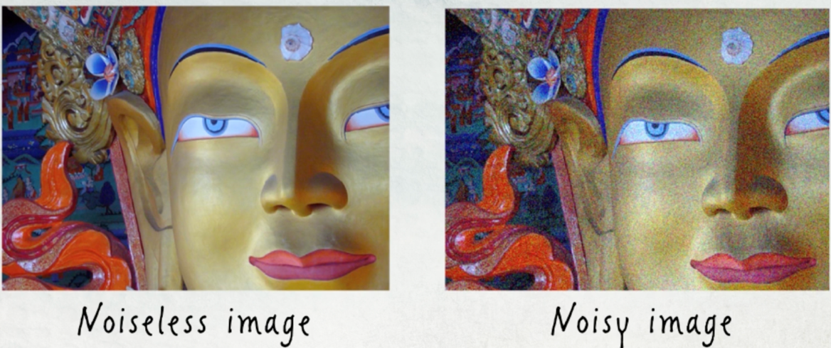

To understand noise a bit better simplify our problem to greyscale (0,255), and restrict our discussion to a one-dimensional function as presented below:

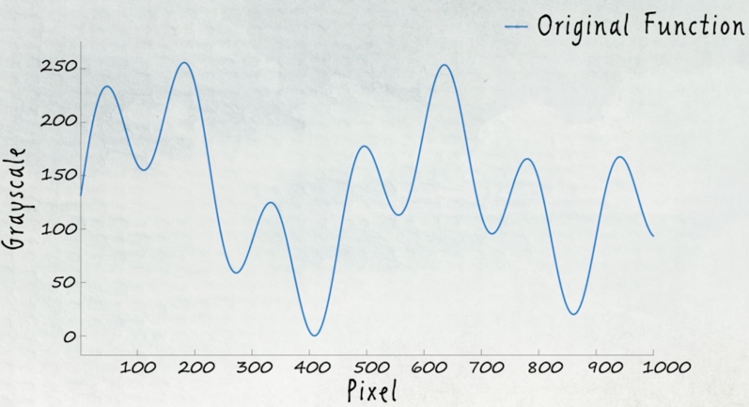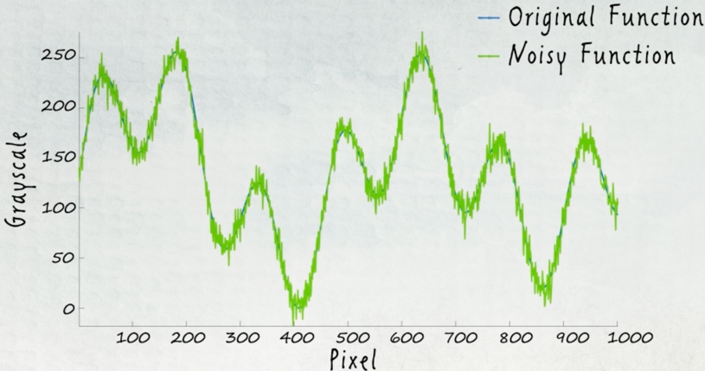

We see that noise creates difference in the values of the function that was obtained from the image but were not in the original scene. So how do we remove noise from the function? **Denoise** the function?

Intuitively, we wish to smoothen the many fluctuation of the function, the process of **averaging** is also applicable in this case. Unlike the anti-aliasing method, instead of defining a new sample value, we replace each value in the noisy function by the average of the values of its neighbourhood.

$$if neighborhood=3 then: f_{new}\left(x\right)= \frac{f\left(x-1\right)+f\left(x\right)+f\left(x+1\right)}{3} and more generally if$$

$$neighborhood =N (a set) then f_{new}\left(x\right)=\frac{1}{|N|}\sum_{x^{'}∈N}{f(x^{'})}$$

The challenge: to Find the correct neighbourhood size to represent the image correctly but not too much which will remove the details (the essence of the image). Remember, we don’t know the original function of the “real scene” so we cannot truly how close are we to the correct scene of the image.

Details

Difference in the function value:

* constant function 🡪 no difference
* Low polynomial Functions🡪 limited detail that can be represented in an image.
* Complex function 🡪 more details can and are represented in the image.

Let I be the image function in **Greyscale** then we can remove noise as follow:

$$I\left(x,y\right)= \frac{1}{{(2k+1)}^{2}}\sum_{i=-k}^{k}{\sum_{j=-k}^{k}{I(x+i,y+j)}}$$

**Image Smoothing**

In **Boxed Averaging** we define a neighbourhood around a matrix and uniformly distribute the weights on the surrounding pixels, usually 3 by 3 matrix, and then sum up the colour value multiplied by the wight of each entry in the matrix which that result becomes the value of the central entry. We then shift the matrix, defining a new central matrix and apply the same process.

When we reach the boundary of the image, we may not have a complete 3,3 matrix. One solution is to assume that the values outside the boundary = 0, another solution is duplication of matrix values.

$$I\left(x,y\right)= \frac{1}{{(2k+1)}^{2}}\sum_{i=-k}^{k}{\sum_{j=-k}^{k}{I(x+i,y+j)}}$$

**Gaussian smoothing** is another type of weighted averaging method, where the weight of the pixels depend on the distance. Where the function is defined as follows:

$$f\left(x\right)= \frac{1}{σ\sqrt{2π}}e^{-\frac{{\left(x-μ\right)}^{2}}{2σ^{2}}}$$

Note that changing $μ$ will moves the centre of the curve and changing $σ$ changes the width of the bell, large sigma 🡪 wide bell.

**Multi-dimensional Gaussian**

$$f\left(x_{1}, x_{2},…,x_{n}\right)= {\frac{1}{\sqrt{{(2π)}^{2}det⁡(\sum{)}}}}^{-(\frac{1}{2}{\left(\vec{x}-\vec{μ}\right)}^{T}{\sum{}}^{-1}\left(\vec{x}-\vec{μ}\right))}$$

∑ - positive definite covariance matrix, defining the different relations between x1 to xn

µ - the vector of expected values

note this, that since this the probability function, it’s integral sums up to 1, where the closure you are to µ vector the higher the density and the further away vectors implies lower density and thus lower integral values. This seems to fit the weighted averaging method for colours in an image.

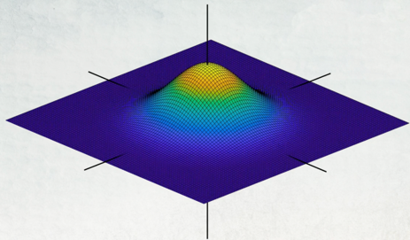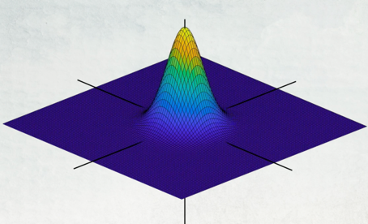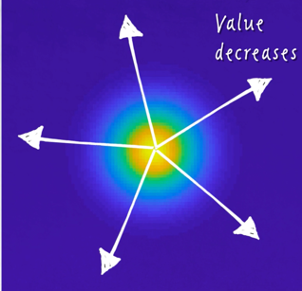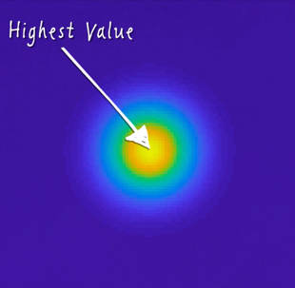

The gaussian is continuous and our image consists of discrete value thus we sample (cut up the Gaussian distribution to a matrix) Normalise each sample point (entry) to sum up to one, looking like this:

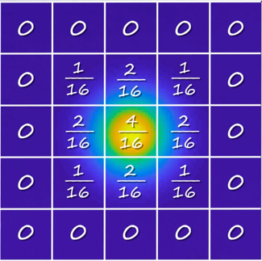

So let’s define G to be the Discrete multi-dimensional Gaussian Matrix $G=(\begin{matrix}\frac{1}{16} & \frac{2}{16} & \frac{1}{16} \\ \frac{2}{16} & \frac{4}{16} & \frac{2}{16} \\ \frac{1}{16} & \frac{2}{16} & \frac{1}{16}\end{matrix})$ then the weighted averaging of a neighbourhood for a new pixel in the image I is:

$$I\left(x,y\right)= \sum_{i=-k}^{k}{\sum_{j=-k}^{k}{G(i,j)I(x+i,y+j)}}$$

Depending on the value of sigma (standard deviation) we can have larger or smaller neighbourhood for the discrete Gaussian kernel (matrix).

**Image Gradients and Edges**

Since details = differences in a function value, we can determine the amount of detail in a particular area but computing the derivative of the function and seeing the value produced. We’ll denote Δx to denote a small change in the x value:

$\frac{d}{dx}f\left(x\right)= \frac{f\left(x+ ∆x\right)-f(x)}{∆x}+O(∆x)$ = **forward differencing** we must check the derivatives of:

Horizontal Direction: $\frac{d}{dx}I\left(x,y\right)≅ \frac{I\left(x+1,y\right)-I\left(x,y\right)}{1}=I\left(x+1,y\right)-I\left(x,y\right)$

Vertical Direction: $\frac{d}{dx}I\left(x,y\right)= \frac{I\left(x,y+1\right)-I\left(x,y\right)}{1}=I\left(x,y+1\right)-I(x,y)$

$\frac{d}{dx}f\left(x\right)= \frac{f\left(x\right)- f\left(x - ∆x\right)}{∆x}+O(∆x)$ = **Backward differencing**

Horizontal Direction: $\frac{d}{dx}I\left(x,y\right)≅ \frac{I\left(x,y\right)-I\left(x-1,y\right)}{1}=I\left(x,y\right)-I\left(x-1,y\right)$

Vertical Direction: $\frac{d}{dx}I\left(x,y\right)= \frac{I\left(x,y\right)-I\left(x,y-1\right)}{1}=I\left(x,y\right)-I(x,y-1)$

$\frac{d}{dx}f\left(x\right)= \frac{f\left(x+ ∆x\right)- f\left(x - ∆x\right)}{2∆x}+O(∆x)$ = **Central differencing**

Greyscale Consideration:

If an image in greyscale holds values between 0-255 🡪 it’s derivative will contain values between -255 to 255. So me must map it back to the 0 to 255 scale. Negative derivative values are mapped to small values which end up darker and positive derivative values are lighter. The vertical detail will be visible in the horizontal derivative of the image, and horizontal detail will be visible in the vertical derivative of the image.

Any direction detail mapping

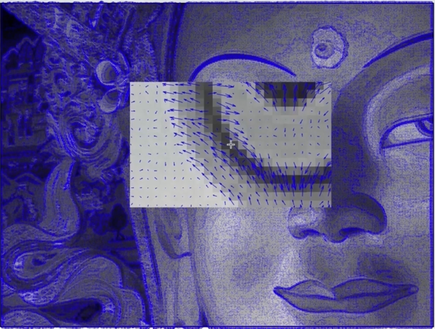 $∇I\left(x,y\right)=(\frac{d}{dx}I\left(x,y\right),\frac{d}{dy}I\left(x,y\right))$

The gradient at (x,y) is the combination of 2 partial derivatives at (x,y) and the gradient of the vector will **point** in the direction of **maximum local change of the function:** usually pointing from the dark areas to the lighter area of the image, in all direction. As such to measure the **magnitude** of detail in a specific area of the image we apply:

$$\left|∇I\left(x,y\right)\right|= \sqrt{{(\frac{d}{dx}I\left(x,y\right))}^{2}+{(\frac{d}{dy}I\left(x,y\right))}^{2}}$$

Important to remember that here **too** we must remap to the 0-255 scale to obtain the greyscale of the image, the image below will present **all** details of the image, also known as the edges of an images.

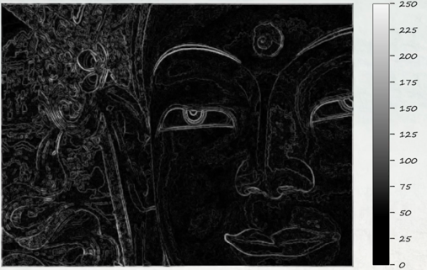

**Aspect Ratio Change**

The aspect ratio of a device is defined as the difference between the width and the height of the of the device. The method of using **seam carving**, allows adjusting the size of an image without losing too much information (at least critical) or producing to many noticeable artifacts.

**Seam Carving**

Seam – a path of connected (sharing an edge/corner of the next pixel) pixels from one end of the image to another, this path is consisting of a sequence of single pixels. We’ll discuss vertical and horizontal.

To maintain the integrity of the image whilst adjusting the size of the image, then we must remove seams that are not “important” to the image, this implies areas of small change in the derivative or areas of less detail.

Thus given an image I, we look at the **magnitude of the gradient** of I at each pixel. For the greyscale image (assuming we’ve converted it), we compute the partial derivative are the **pixel differences** in the horizontal and vertical direction. Where the magnitude of the gradient can be measured using the squared root of the squared components.

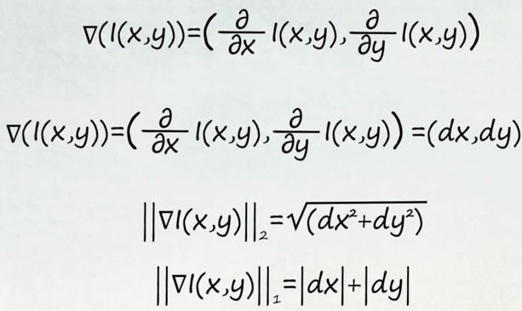

Using this computation across the whole image we’d be computing the values of importance of the pixels, i.e. the larger the value the more important the pixel, and as such we must consider it greatly in seam carving. Thus, we wish to determine a seam which has an overall minimum cost. Let S denote a seam chosen in the image, and E denotes the cost of the seam. Among all the seams our goal is to find the seam being the min, S* = argmin(E(S))

$$E\left(S\right)= \sum_{(x,y)∈S}{E(I\left(x,y\right))}$$

Finding the minimal Seam

We can apply a dynamic programming approach, starting from the top of the image. We determine the path of minimum cost by always choosing the minimum of the 3 connecting pixels above our current pixel i.e. I(i,j) check I(i,j-1), I(i-1, j-1) and I(i+1,j-1).

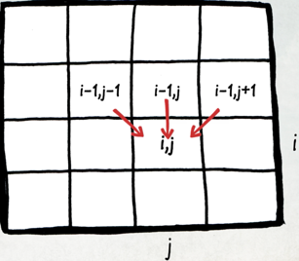

So assume that the gradient magnitude of each pixel is E(i,j), we initialise a matrix M by storing in each I(i,j) E(i,j).

$$M\left(i,j\right)=\left\{\begin{aligned}E\left(i,j\right), if i=0 \\ E\left(i,j\right)+min⁡\{M\left(i-1,j-1\right), M\left(i-1,j\right), M\left(i-1,j+1\right)\}\end{aligned}\right.$$

|  |  |  |  |
| --- | --- | --- | --- |
| 5 | 8 | 12 | 3 |
| 9 | 2 | 3 | 9 |
| 7 | 3 | 4 | 2 |
| 5 | 4 | 7 | 8 |

|  |  |  |  |
| --- | --- | --- | --- |
| 5 | 8 | 12 | 3 |
| 5+9 | 2+5 | 3+3 | 9 +3 |
| 7+(2+5) | 3 + (3+3) | 4 + (3+3) | 2 + (3+3) |
| 5 + (3+3+3) | 4 + (3+3+3) | 7 + (2+3+3) | 8 + (2+3+3) |

|  |  |  |  |
| --- | --- | --- | --- |
| 5 | 8 | 12 | 3 |
| 14 | 7 | 6 | 12 |
| 14 | 9 | 10 | 8 |
| 14 | 13 | 15 | 13 |

To run seam carving k times, we just apply the algorithm k times on the resulting image. As Seam carving is a local operation there’s no need to recompute the gradient magnitude of the pixels, only the pixels surrounding the carving that occurred in the k-1 iteration. The complexity of this algorithm is linear on the number of pixels in the image.